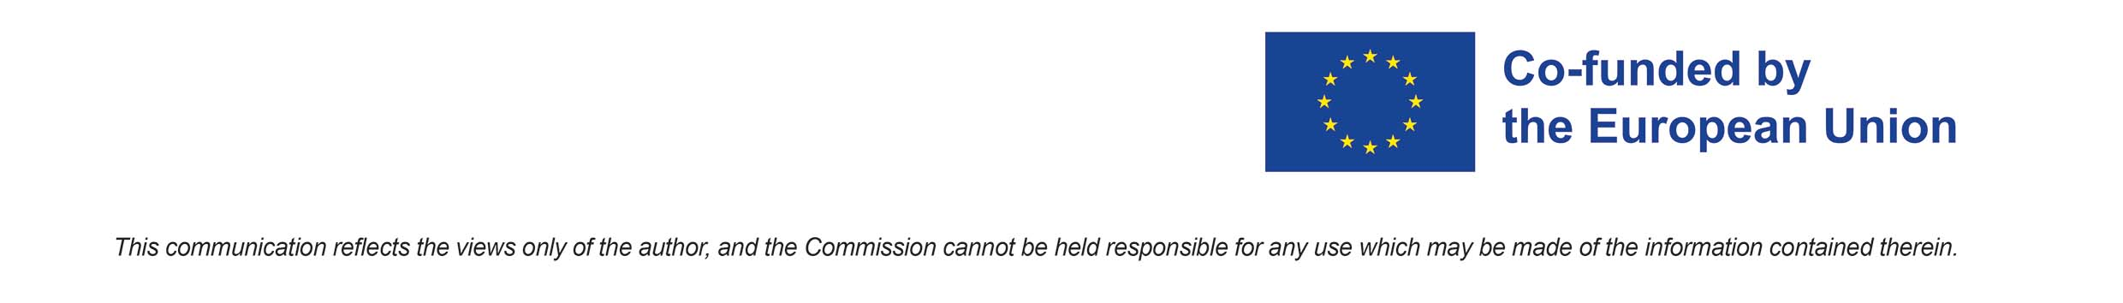
Application form for
Strengthening Creativity and Critical thinking for the young people - S.C.O.O.P. project
ERASMUS+ KA1 2021-2027
KA152-YOU - Mobility of young people


Youth Exchange: 18 - 25 May 2022
Casale Monferrato and Monferrato area, Piedmont - Italy

Please return this application form to Sending organization progetti@ecomuseopietracantoni.it before Deadline: 21 April 2022

Surname

First name

Place of birth

Date of birth

Gender

Address of residence

City of residence

Country

Telephone number

Email address

Any medical or other need, or special dietary (e.g. vegetarian, vegan, no pork, halal, intolerances or allergies, …)
Phone n. for Emergency contact

Do you need a visa to enter Italy?

If you need Visa, please fill this box
Passport number
Place of birth
Address
Issued in (location)
Issued on (date)
Expiration date
Location of the Embassy

- Please describe your previous experience (if any) with EU/international mobility:

- Please describe your previous experiences (if any) with non-formal education and/or youth initiatives:

- What are your expectations about this Youth Exchange?

- How do you think you can contribute to the SCOOP activities?

- In which way you could multiply the results of the Youth Exchange (after your back home)?

- REQUESTED ANNEX: Please send your CV in Europass format.

